Skeleton of Code & Database Integration
* Skeleton of Codes: You can find them in the Skeleton-Code ZIP file
* Database Integration Code: You can find them in the Database-Integration ZIP file
- We have integrated the database into some use cases through the data access classes in our Design Class Diagram.
- We have generated the skeleton of the codes, then integrated some SQL queries in some use cases.
- Create Account DCD

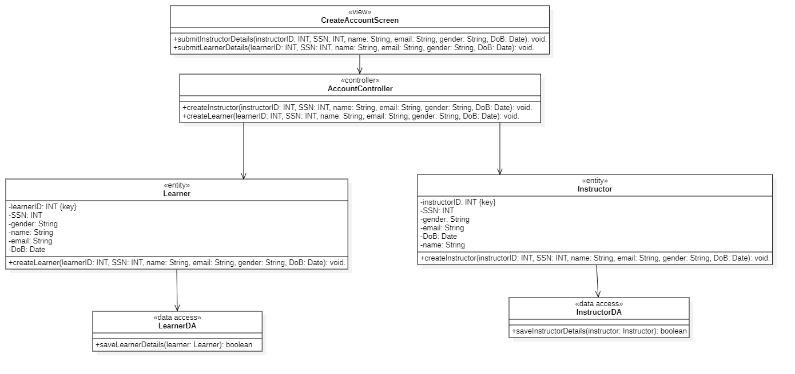

- Create Course DCD
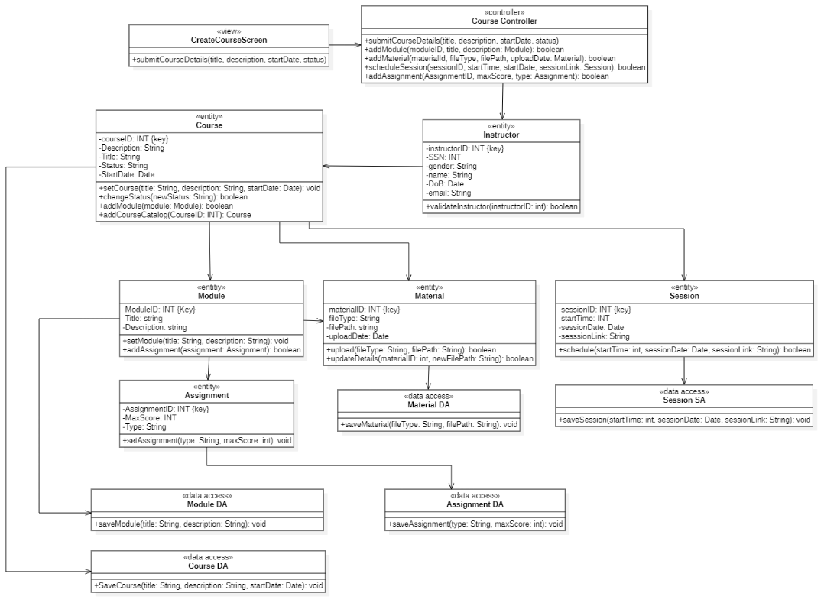
- View available courses DCD
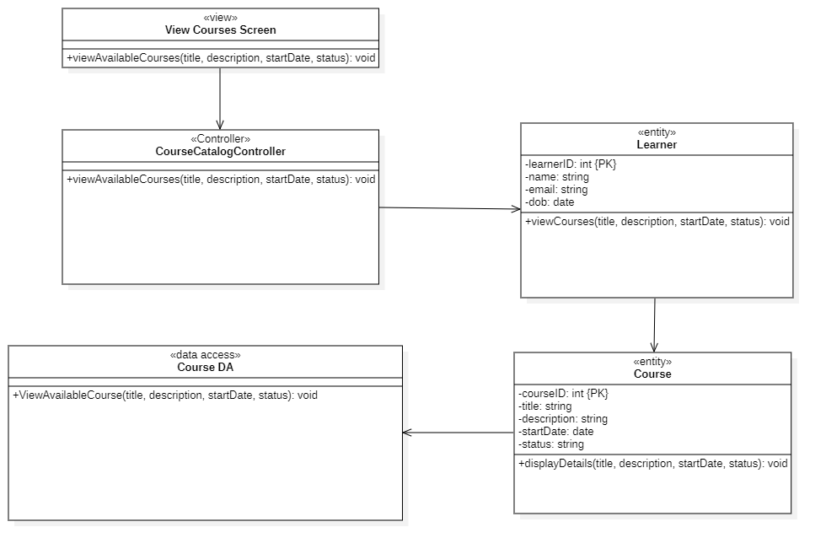
We have used these use cases to connect the database to these data access classes and show that the software system is successfully integrated with our Educertify Database.

Here are some snippets of our code running and reflecting on our database.
(Integration Successful)
1. Create Account (Learner)
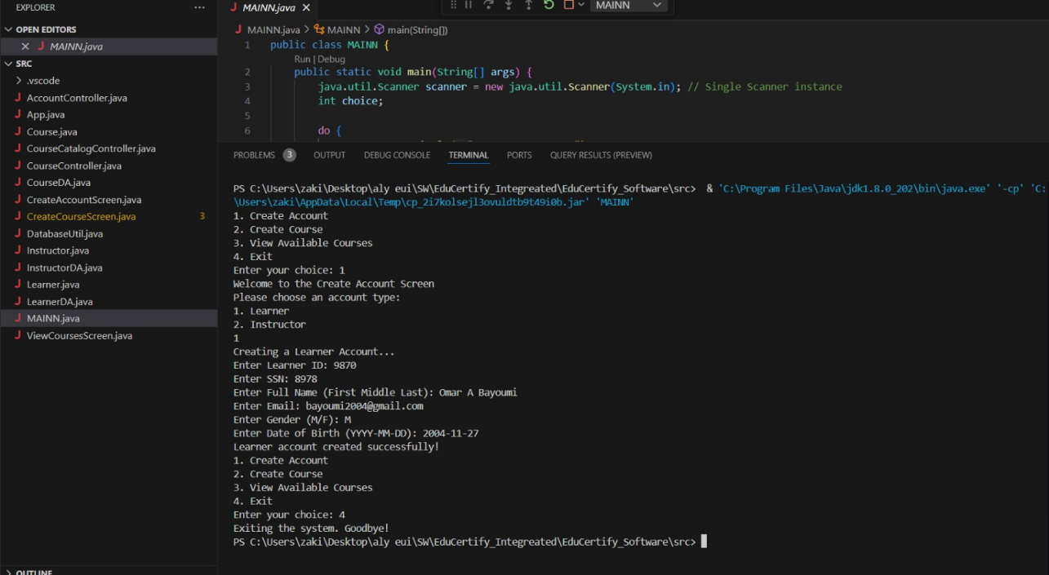
Reflection in database
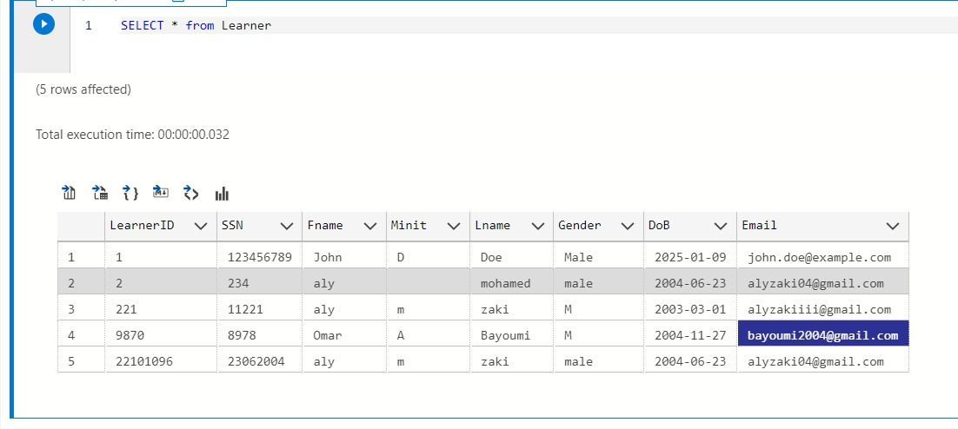
2. Create Account (Instructor)
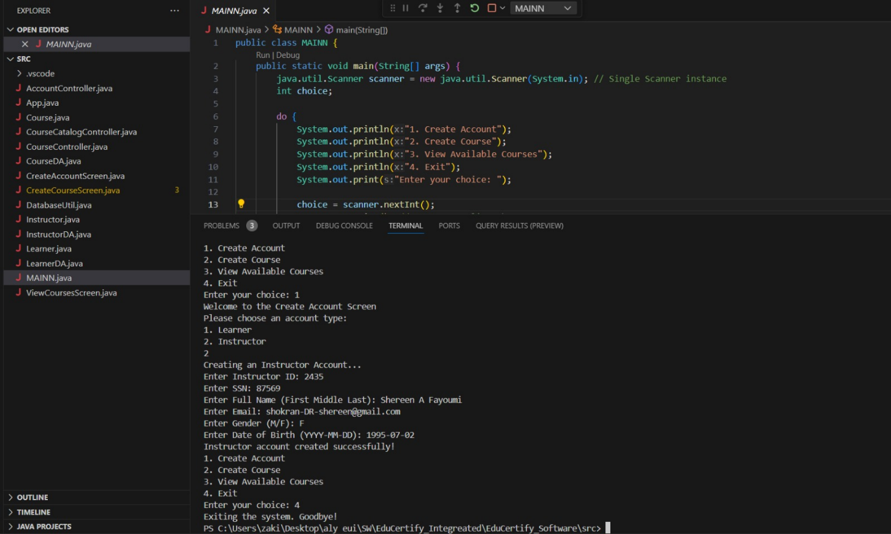
Reflection in database
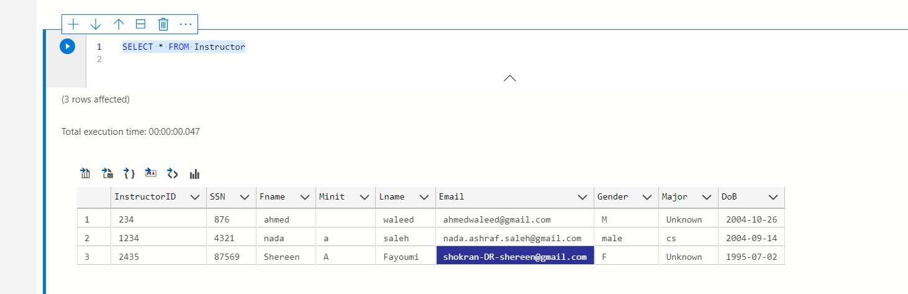

3. Create Course
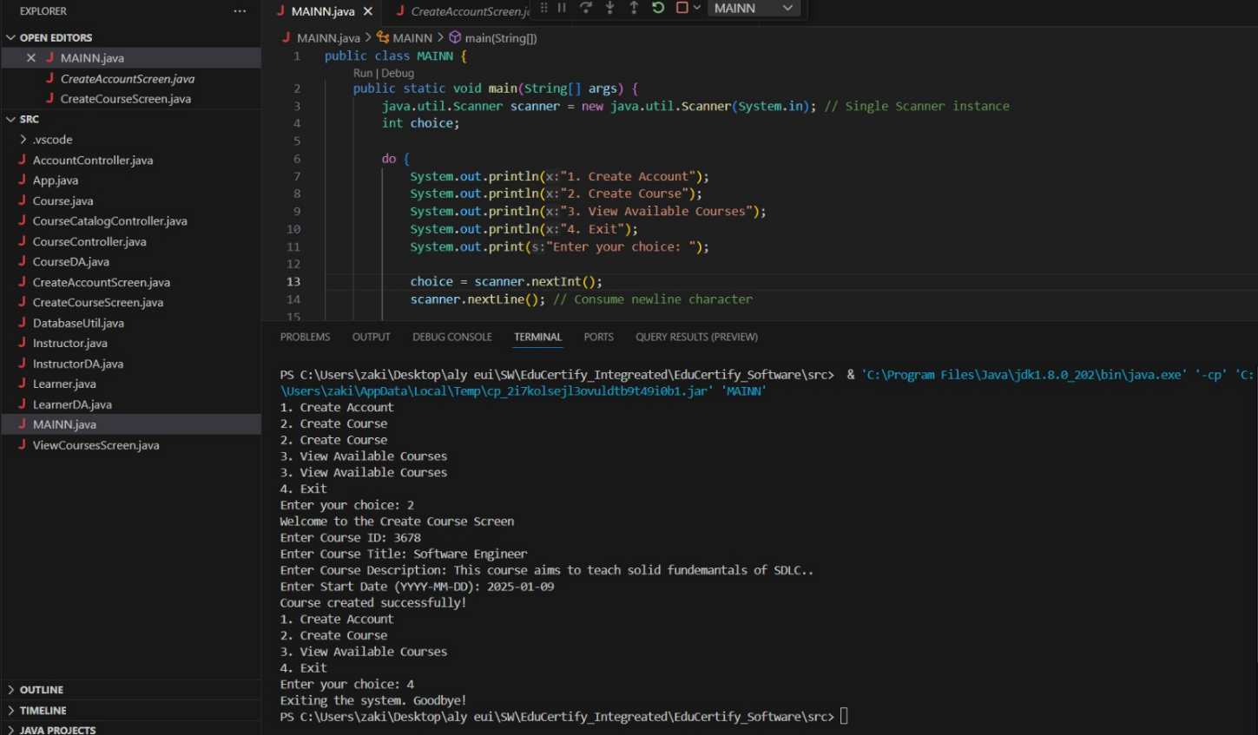
Reflection in database
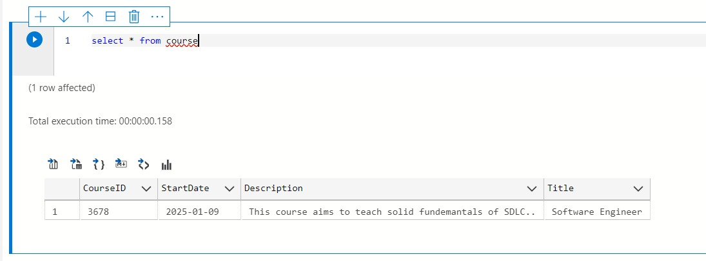

4. View Available courses
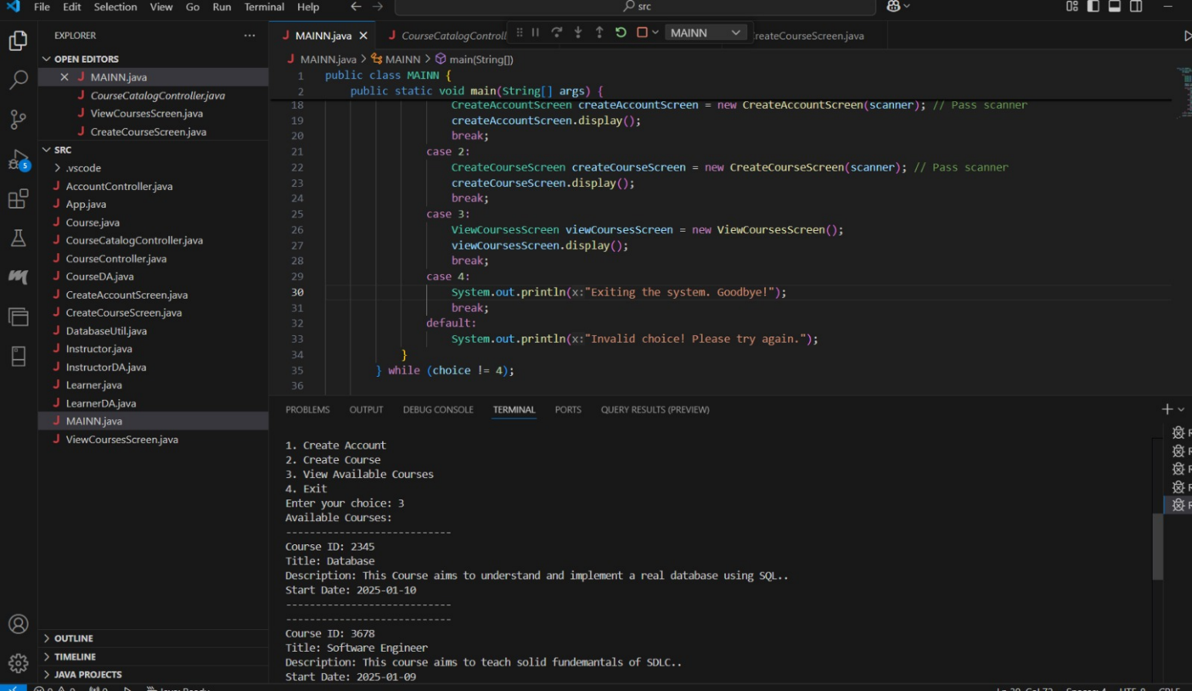
Reflection in database
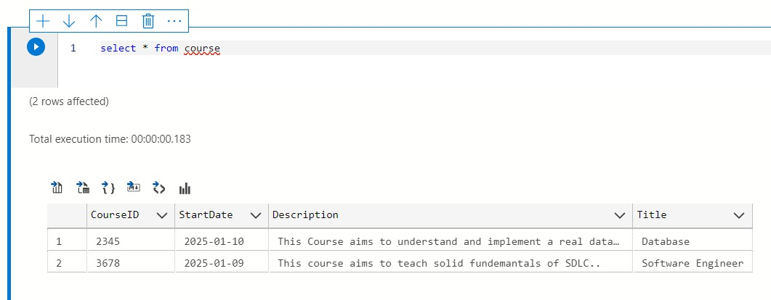

By
Nada Ashraf
Aly Zaki
Ahmed Waleed
Omar Bayoumi

